Summer Term 2025 Newsletter - Maple Class
Welcome back to the Summer Term; we’ve already been very busy learners since the start of term. We have got lots of exciting activities planned for the children this term.
Our learning challenge questions for this term are ‘Why do Humans have skeletons and Muscles?’ and ‘How are rivers formed?’
Please see the key objectives below.
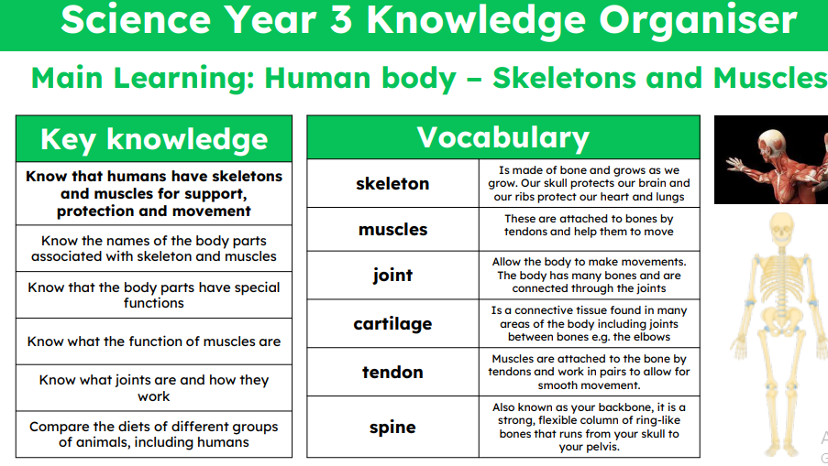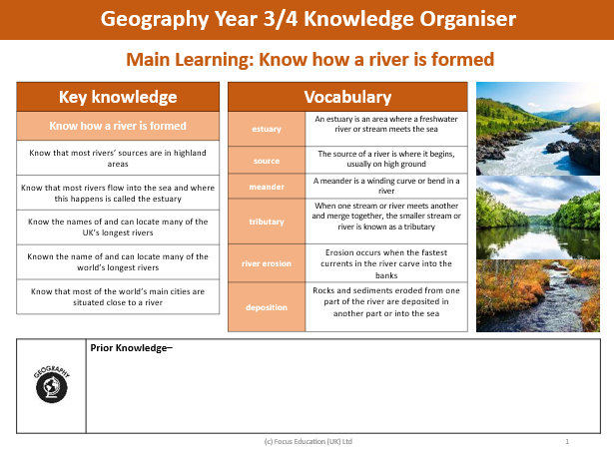
The story we will be focussing on in English is The Wind in the Willows, Kenneth Grahame. This links with the river work that the children will be learning about in their Geography lessons.
We are also going to be reading ‘A River’ by Marc Martin, as our class book.
In Maths we are using the White Rose maths scheme supplemented with additional useful resources. This term we will be covering work on Decimals (Y4) Mass (Y3) Measurement: Time, Statistics and Geometry: Properties of shape (including Y4 Position and Direction). Each morning Maple class complete short activities to practise their times tables which is an essential skill for all their maths learning. This term, Year 4 children will be completing a Multiplication Tables Check (MTC), to test their knowledge and recall of their times tables.
Mathletics is an excellent curriculum resource which we would encourage you to utilise at home with the children to complement work being taught in the classroom. Each child has their own username and password to access Mathletics.
The children have a weekly spellings test on a Thursday. They will receive a copy of their new spellings on Friday.
Reading is an essential part of children’s educational development and we expect children to read every day. They have the freedom to choose their own book from our collection (children are advised to read their book band level but are not limited to this, as we promote a passion for reading based on children’s interests). We ask that your child records their reading in their diary themselves and when you listen to their reading, please could you record this and any comments. Reading Eggs is an online reading resource that all the children have access to. It is very helpful to assist with reading comprehension. All children have their own username and password, it is the same as Mathletics.
The children have swimming every Friday afternoon (thank you for ensuring your children are prepared for this every week – lessons are going brilliantly). Children must come dressed in their PE kit on Thursdays. The children will be outside, where possible, so please make sure they are dressed appropriately for all weather conditions.
Here’s to a super term ahead! If you have any questions, please don’t hesitate to ask us. Thank you for your ongoing support.
Mrs Christy and Miss Long

