Autumn Term 2024 Newsletter
Maple Class
Welcome back to the Autumn Term and welcome to Maple class; we hope you have all enjoyed the summer break. Your class teachers this year are Miss Long (Monday and Tuesday), and Mrs Christy (Wednesday to Friday). Please feel free to come and say hello!
We have got lots of exciting activities planned for Maple class this term. Our learning challenge questions for this term are ‘How did Britain change?’ (Stone Age) and ‘Who were the Romans and what did we learn from them?’.
The story we will be focussing on for the first half term is Stone Age Boy by Satoshi Kitamura, followed in the second half of the term with Roman Diary by Richard Platt. These books link with the work the children will be learning about in their history lessons this term.
Please see the key objectives below:
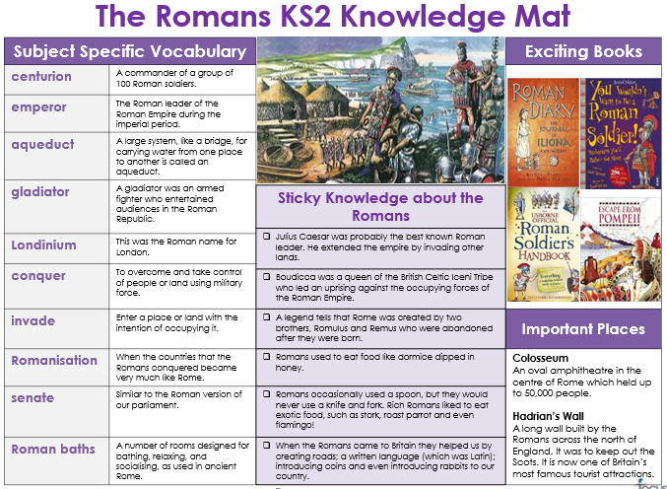
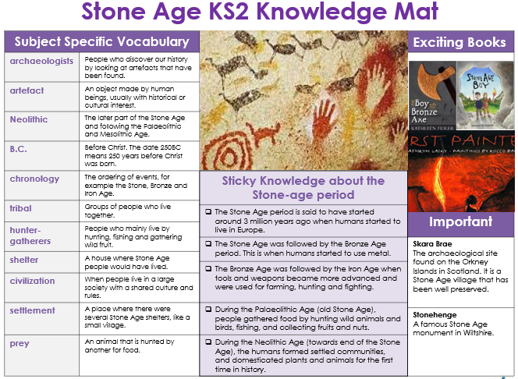

Science
In Science we are going to be learning about electricity. Our Learning Challenge question is ‘What is electricity and why is it so important in our lives?’. After half term our learning question is, ‘What are the main types of rocks on our Earth?’.
Please see the key objectives below:
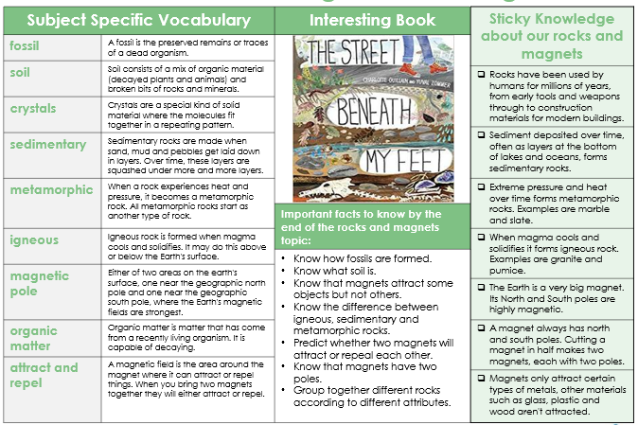
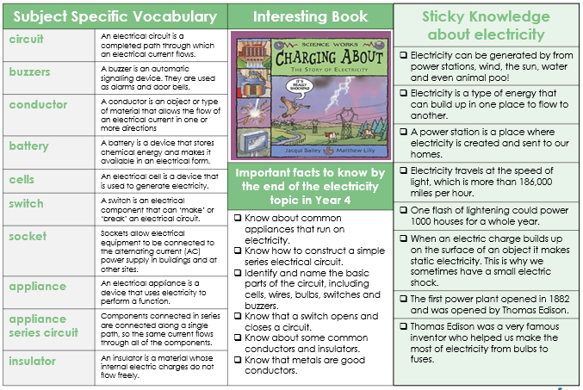

Reading
Reading is an essential part of children’s educational development and we expect children to read every day. They have the freedom to choose their own book from our collection (children are advised to read their book band level but are not limited to this, as we promote a passion for reading based on children’s interests). We ask that your child records their reading in their diary at least three times a week. When you listen to their reading, please could you record this and any comments.

Maths
In Maths we are using the White Rose maths scheme supplemented with additional useful resources. This term we will be covering place value, addition and subtraction, multiplication and division and area. Each week Maple class will focus on a times table activity and are encouraged to practise teacher - guided work at home (the children will be told what to do for this). In the summer term, Year 4 children will be completing a Multiplication Tables Check (MTC), to test their knowledge and recall of their times tables. Mathletics is an excellent curriculum resource which we would encourage you to utilise at home with the children to complement work being taught in the classroom. Each child has their own username and password to access Mathletics.
P.E
The children will have P.E every Thursday and Friday. Children must come dressed in their PE kits on both of these days. The children will be outside, where possible, so please make sure they are dressed appropriately for all weather conditions.
Spellings
The children have a weekly spelling test on a Thursday, they will receive a copy of their new spellings on Friday.
We are always on the lookout for parent readers so please speak to either of us if you are interested in listening to readers for an hour or two each week.
Also, please keep checking our class page on the school website as we will update this as regularly as we can, showing the wonderful things we do in Maple class!
If you have any questions then please do not hesitate to come and see us.
Mrs Christy and Miss Long

