Summer Term 2023 Newsletter
Maple Class
Welcome back to the Summer Term; we hope you have all had a lovely Easter. We have got lots of exciting activities planned for the children.
Our learning challenge questions for this term are ‘Why do Humans have skeletons and Muscles?’ and ‘How are rivers formed?’
Please see the key objectives below.
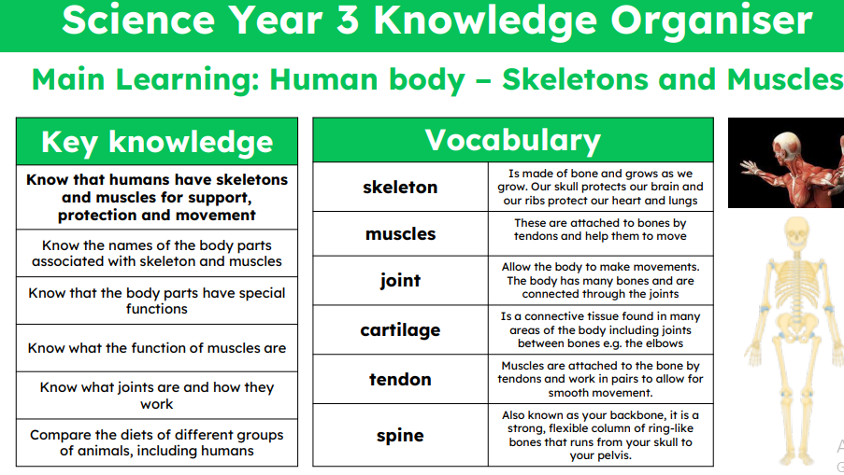
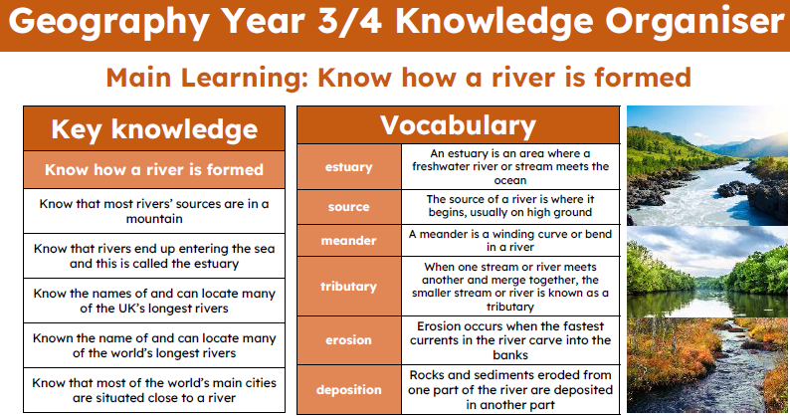

The stories we will be focussing on for this term include Funny Bones by Janet and Allan Alhberg and Wind in the Willows by Kenneth Grahame . These books link with the work the children will be learning about in their Geography and Science lessons. We are also going to be reading Danny the Champion of the World as our class book.
In Maths we are using the White Rose maths scheme supplemented with additional useful resources. This term we will be covering work on Fractions (Y3),Decimals (Y4), Time, Shape, Statistics, and Position and Direction(Y4). Each morning Maple class complete short activities to practise their times tables which is an essential skill for all their maths learning. This term, Year 4 children will be completing a Multiplication Tables Check (MTC), to test their knowledge and recall of their times tables.
Mathletics is an excellent curriculum resource which we would encourage you to utilise at home with the children to complement work being taught in the classroom. Each child has their own username and password to access Mathletics.
The children have a weekly spellings test on a Thursday. They will receive a copy of their new spellings which will also be available on Teams. The children will also receive a code so they can practise their spellings on Spelling Frame.
Reading is an essential part of children’s educational development and we expect children to read every day. They have the freedom to choose their own book from our collection (children are advised to read their book band level but are not limited to this, as we promote a passion for reading based on children’s interests). We ask that your child records their reading in their diary and when you listen to their reading, please could you record this and any comments. Reading Eggs is an online reading resource that all the children have access to. It is very helpful to assist with reading comprehension. All children have their own username and password, it is the same as Mathletics.
The children will have PE every Monday and Thursday. Children must come dressed in their PE kits on both of these days. The children will be outside, where possible, so please make sure they are dressed appropriately for all weather conditions.
If you have any questions or worries then please do ask.
Mrs Montgomery and Mrs Christy

